E-Reader Books:
Broken Man on a Halifax Pier by Lesley Choyce
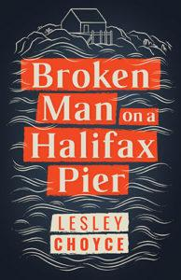
Fifty-five-year-old Charles Howard has lost his long-time journalism job and has been swindled out of his life savings. Standing by the edge of Halifax Harbour on a foggy morning, contemplating his dismal future, his ritual of self-pity is interrupted with the appearance of the mysterious and beguiling Ramona Danforth. And so begins a most interesting relationship.
On a whim, Charles asks Ramona to drive him to his childhood home, Stewart Harbour, a fishing village populated by rugged individualists far down Nova Scotia’s remote Eastern Shore. Charles left the Harbour immediately after graduating from high school and never looked back. And now that he's returned, the past starts catching up with him in ways he could never have imagined.

Five Little Indians by Michelle Good
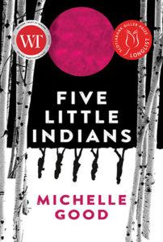
Winner of the 2018 HarperCollins/UBC Prize for Best New Fiction Michelle Good's FIVE LITTLE INDIANS, told from the alternating points of view of five former residential school students as they struggle to survive in 1960s Vancouver—one finding her way into the dangerous world of the American Indian movement; one finding unexpected strength in motherhood; and one unable to escape his demons - and the bonds of friendship that sustain them, inspired by the author's experiences.

I Overcame My Autism and All I Got Was this Lousy Anxiety Disorder by Sarah Kurchak
Growing up undiagnosed in small-town Ontario in the eighties and nineties, Kurchak realized early that she was somehow different from her peers. She discovered an effective strategy to fend off bullying: she consciously altered nearly everything about herself—from her personality to her body language. She forced herself to wear the denim jeans that felt like being enclosed in a sandpaper iron maiden. Every day, she dragged herself through the door with an elevated pulse and a churning stomach, nearly crumbling under the effort of the performance. By the time she was finally diagnosed with autism at twenty-seven, she struggled with depression and anxiety largely caused by the same strategy she had mastered precisely. She came to wonder, were all those years of intensely pretending to be someone else really worth it?
Tackling everything from autism parenting culture to love, sex, alcohol, obsessions and professional pillow fighting, Kurchak’s enlightening memoir challenges stereotypes and preconceptions about autism and considers what might really make the lives of autistic people healthier, happier and more fulfilling.

Seven by Farzana Doctor
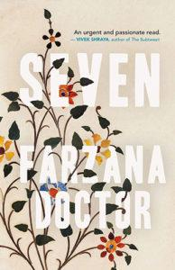
When Sharifa accompanies her husband on a marriage-saving trip to India, she thinks that she's going to research her great-great-grandfather, a wealthy business leader and philanthropist. What captures her imagination is not his rags-to-riches story, but the mystery of his four wives, missing from the family lore. She ends up excavating much more than she had imagined.
Sharifa's trip coincides with a time of unrest within her insular and conservative religious community, and there is no escaping its politics. A group of feminists is speaking out against khatna, an age-old ritual they insist is female genital cutting. Sharifa’s two favourite cousins are on opposite sides of the debate and she seeks a middle ground. As the issue heats up, Sharifa discovers an unexpected truth and is forced to take a position.

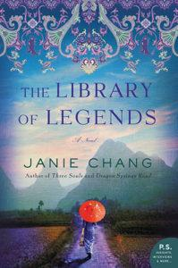
The Library of Legends by Janie Chang
China, 1937. When Japanese bombs begin falling on the city of Nanking, nineteen-year-old Hu Lian and her classmates at Minghua University are ordered to flee. Lian and a convoy of students, faculty and staff must walk 1,000 miles to the safety of China’s western provinces, a journey marred by the constant threat of aerial attack. And it is not just the refugees who are at risk; Lian and her classmates have been entrusted with a priceless treasure: a 500-year-old collection of myths and folklore known as the Library of Legends.
The students’ common duty to safeguard the Library of Legends creates unexpected bonds. Lian becomes friends and forms a cautious romance with the handsome and wealthy Liu Shaoming. But after one classmate is arrested and another one is murdered, Lian realizes she must escape before a family secret puts her in danger too. Accompanied by Shao and his enigmatic maidservant, Sparrow, Lian makes her way to Shanghai in the hopes of reuniting with her mother.
During the journey, Lian learns of the connection between her two companions and a tale from the Library of Legends, The Willow Star and the Prince. This revelation comes with profound consequences, for as the ancient books travel across China, they awaken immortals and guardian spirits who embark on an exodus of their own, one that will change the country’s fate forever.

They Said This Would be Fun by Eternity Martis
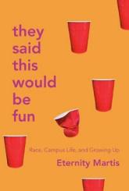
A booksmart kid from Toronto, Eternity Martis was excited to move away to Western University for her undergraduate degree. But as one of the few Black students there, she soon discovered that the campus experiences she'd seen in movies were far more complex in reality. Over the next four years, Eternity learned more about what someone like her brought out in other people than she did about herself. She was confronted by white students in blackface at parties, dealt with being the only person of colour in class and was tokenized by her romantic partners. She heard racial slurs in bars, on the street, and during lectures. And she gathered labels she never asked for: Abuse survivor. Token. Bad feminist. But, by graduation, she found an unshakeable sense of self—and a support network of other women of colour.
Using her award-winning reporting skills, Eternity connects her own experience to the systemic issues plaguing students today. It's a memoir of pain, but also resilience.

A God in Ruins, by Kate Atkinson
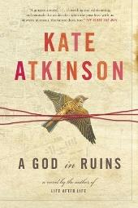
Kate Atkinson's dazzling Life After Life explored the possibility of infinite chances, following Ursula Todd as she lived through the turbulent events of the last century again and again. Her new novel tells the story of Ursula Todd's beloved younger brother Teddy--would-be poet, RAF bomber pilot, husband, and father--as he navigates the perils and progress of the 20th century. For all Teddy endures in battle, his greatest challenge is facing the difficulties of living in a future he never expected to have. The stunning companion to Life After Life, A God in Ruins explores the loss of innocence, the fraught transition from the war to peace time, and the pain of being misunderstood, especially as we age. Proving once again that Kate Atkinson is "one of the finest writers working today" (The Chicago Tribune), A God in Ruins is the triumphant return of a modern master.

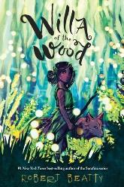
Willa of the Wood, by Robert Beatty
From #1 New York Times bestselling author Robert Beatty comes a spooky, thrilling new series set in the magical world of Serafina. Move without a sound. Steal without a trace. Willa, a young nightspirit of the Great Smoky Mountains, is her clan's best thief. She creeps into the homes of day-folk in the cover of darkness and takes what they won't miss. It's dangerous work—the day-folk kill whatever they do not understand. But when Willa's curiosity leaves her hurt and stranded in a day-folk man's home, everything she thought she knew about her people—and their greatest enemy—is forever changed.

Front Desk, by Kelly Yang
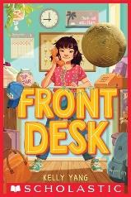
Mia Tang has a lot of secrets.
Number 1: She lives in a motel, not a big house. Every day, while her immigrant parents clean the rooms, ten-year-old Mia manages the front desk of the Calivista Motel and tends to its guests.
Number 2: Her parents hide immigrants. And if the mean motel owner, Mr. Yao, finds out they've been letting them stay in the empty rooms for free, the Tangs will be doomed.
Number 3: She wants to be a writer. But how can she when her mom thinks she should stick to math because English is not her first language?
It will take all of Mia's courage, kindness, and hard work to get through this year. Will she be able to hold on to her job, help the immigrants and guests, escape Mr. Yao, and go for her dreams?

You Go First by Erin Entrada Kelly
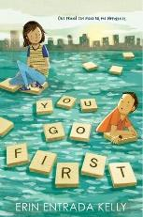
Twelve-year-old Charlotte Lockard and eleven-year-old Ben Boxer are separated by more than a thousand miles. On the surface, their lives seem vastly different—Charlotte lives near Philadelphia, Pennsylvania, while Ben is in the small town of Lanester, Louisiana. Charlotte wants to be a geologist and keeps a rock collection in her room. Ben is obsessed with Harry Potter, presidential history, and recycling. But the two have more in common than they think. They’re both highly gifted. They’re both experiencing family turmoil. And they both sit alone at lunch.
Over the course of a week, Charlotte and Ben—online friends connected only by a Scrabble game—will intersect in unexpected ways as they struggle to navigate the turmoil of middle school. You Go First reminds us that no matter how hard it is to keep our heads above troubled water, we never struggle alone.
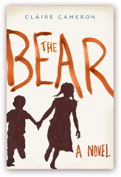
The Bear, by Claire Cameron
Told from the point of view of a six-year-old child, The Bear is the story of Anna and her little brother, Stick--two young children forced to fend for themselves in Algonquin Park after a black bear attacks their parents. A gripping and mesmerizing exploration of the child psyche, this is a survival story unlike any other, one that asks what it takes to survive in the wilderness and what happens when predation comes from within.

Hazardous Duty, by W.E.B. Griffin
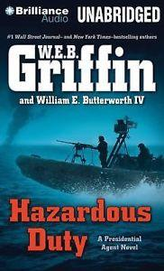
Colonel Charley Castillo is back in action. Mexican drug cartels are shooting up the streets of Laredo and El Paso. Somali pirates are holding three U.S. tankers for ransom. The President has had enough—he needs to get hold of Colonel Charley Castillo and his merry band of fighters and put them on the case. Unfortunately, that might be impossible.

Deadline, by Sandra Brown
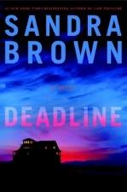
Dawson Scott is a well-respected journalist recently returned from Afghanistan. Haunted by everything he experienced, he's privately suffering from battle fatigue which is a threat to every aspect of his life. But then he gets a call from a source within the FBI. A new development has come to light in a story that began 40 years ago. It could be the BIG story of Dawson's career, one in which he has a vested interest.

The Silence of Bonaventure Arrow, by Rita Leganski
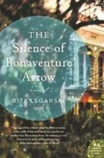
The Silence of Bonaventure Arrow is the tale of a mute boy whose gift of wondrous hearing reveals family secrets and forgotten voodoo lore, and exposes a murder that threatens the souls of those who love him.

Maya’s Notebook, by Isabel Allende
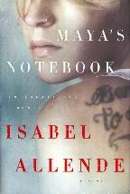
To escape a life of drugs, crime and prostitution, nineteen-year-old Maya Vidal flees California to a remote island off the coast of Chile. There, in the company of a torture survivor, a lame dog and other unforgettable characters, Maya writes her story, which includes pursuit by a gang of assassins, the police, the FBI and Interpol. In the process, she unveils a terrible family secret, comes to understand the meaning of love and loyalty and initiates the greatest adventure of her life: the journey into her own soul.

Ripper, by Isabell Allende
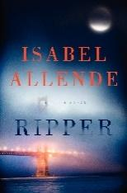
The Jackson women, Indiana and Amanda, have always had each other. Yet, while their bond is strong, mother and daughter are as different as night and day. When a string of strange murders occurs across the city, Amanda plunges into her own investigation, discovering, before the police do, that the deaths may be connected. But the case becomes all too personal when Indiana suddenly vanishes.

Storm Front, by John Sandford
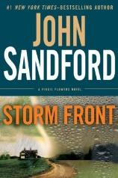
An ancient relic is unearthed during an archaeological dig. A Minnesota college professor is keeping a secret that could change the world’s history as we know it. For Virgil Flowers, the link between the two is inescapable—and his investigation, more dangerous and far-reaching than he can possibly imagine.

Dark Wolf, by Christine Feehan
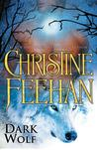
He is Carpathian. Ancient and unassailable. She is human. Young and vulnerable. Without her, he will not survive. Caught between two warring species, Dimitri has spent centuries hunting the undead to keep his people free and humans safe. He has survived honorably when others have chosen to give up their souls. Now, marked for extermination by the Lycans, Dimitri finds himself alone, and fearing for his life. But salvation is coming, no Lycan would ever suspect someone like Skyler to dare mount a secret rescue operation.

The Museum of Extraordinary Things, by Alice Hoffman
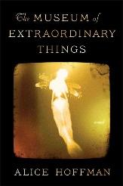
Coralie Sardie is the daughter of the sinister impresario behind The Museum of Extraordinary Things, a Coney Island freak show that thrills the masses. An exceptional swimmer, Coralie appears as the Mermaid in her father’s “museum,” alongside performers like the Wolfman and the Butterfly Girl. One night Coralie stumbles upon a striking young man taking pictures of moonlit trees in the woods off the Hudson River. The dashing photographer is Eddie Cohen. When Eddie photographs the infamous Triangle Shirtwaist Factory fire, he becomes embroiled in the mystery behind a young woman’s disappearance. And he ignites the heart of Coralie.

Mirage, by Clive Cussler, Jack Du Brul
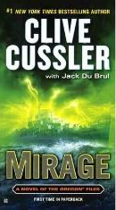
In October 1943, a U.S. destroyer sailed out of Philadelphia and supposedly vanished, the result of a Navy experiment with electromagnetic radiation. The story was considered a hoax—but now Juan Cabrillo and his Oregon colleagues aren’t so sure. There is talk of a new weapon soon to be auctioned, something very dangerous to America’s interests, and the rumors link it to the great inventor Nikola Tesla, who was working with the Navy when he died in 1943. Was he responsible for the experiment? Are his notes in the hands of enemies? As Cabrillo races to find the truth, he discovers there is even more at stake than he could have imagined—but by the time he realizes it, he may already be too late.

The Art of Hearing Heartbeats, by Jan-Philipp Sendker
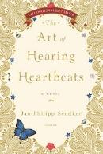
A poignant and inspirational love story set in Burma, The Art of Hearing Heartbeats spans the decades between the 1950s and the present. When a successful New York lawyer suddenly disappears without a trace, neither his wife nor his daughter Julia has any idea where he might be. Until they find a love letter he wrote many years ago, to a Burmese woman they have never heard of. Julia decides to travel to the village where the woman lived.

Above All Things, Tanis Rideout
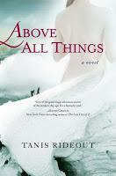
Brilliantly weaves together the harrowing story of George Mallory's ill-fated 1924 attempt to be the first man to conquer Mount Everest, with that of a single day in the life of his wife as she waits at home in England for news of his return. A captivating blend of historical fact and imaginative fiction.

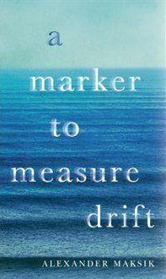
A Marker to Measure Drift, by Alexander Maksik
On an island somewhere in the Aegean, Jacqueline, a young Liberian woman, veers between starvation and satiety, between the brutality of her past and the precarious uncertainty of her present in the aftermath of experiences so unspeakable that she prefers homeless numbness to the psychological confrontation she knows is inevitable. Hypnotic, highly sensual, exquisitely written, and extraordinary in its depiction of both pleasure and pain, of excruciating physical and spiritual hungers.

The Husband’s Secret, by Liane Moriarty
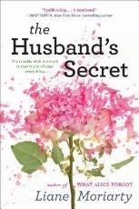
Imagine your husband wrote you a letter, to be opened after his death. Imagine, too, that the letter contains his deepest, darkest secret—something with the potential to destroy not only the life you have built together, but the lives of others as well. And then imagine that you stumble across that letter while your husband is still very much alive. Cecilia Fitzpatrick has achieved it all—she’s an incredibly successful businesswoman, a pillar of her small community, a devoted wife and mother. Her life is as orderly and spotless as her home. But that letter is about to change everything—and not just for her.

The Goldfinch, by Donna Tartt
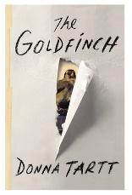
Theo Decker, a 13-year-old New Yorker, miraculously survives an accident that kills his mother. Abandoned by his father, Theo is taken in by the family of a wealthy friend. Bewildered by his strange new home on Park Avenue, disturbed by schoolmates who don't know how to talk to him, and tormented above all by his longing for his mother, he clings to the one thing that reminds him of her: a small, mysteriously captivating painting that ultimately draws Theo into the underworld of art. As an adult, Theo moves silkily between the drawing rooms of the rich and the dusty labyrinth of an antiques store where he works. He is alienated and in love--and at the center of a narrowing, ever more dangerous circle.

The Ghost Bride, by Yangsze Choo
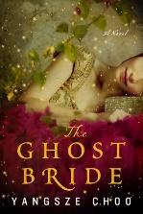
The Ghost Bride, is a startlingly original novel infused with Chinese folklore, romantic intrigue, and unexpected supernatural twists. Li Lan, the daughter of a respectable Chinese family in colonial Malaysia, hopes for a favorable marriage, but her father has lost his fortune, and she has few suitors. Instead, the wealthy Lim family urges her to become a “ghost bride” for their son, who has recently died under mysterious circumstances. Rarely practiced, a traditional ghost marriage is used to placate a restless spirit. Such a union would guarantee Li Lan a home for the rest of her days, but at what price?

